Formatting a Word Document for Respondus Import
You can create the following types of questions in a Word document for importing into Respondus:
- Multiple Choice
- True False
- Multiple Response
- Matching
- Essay (Paragraph)

Mulitple Choice and True False
Each question should be on its own line and should begin with the question number followed by a period and space. Each answer option should be on its own separate line immediately following the question. The correct answer should be indicated by using an asterisk (*) directly preceding the correct option without a space. See the example below:
1. How many colors are in a rainbow?
a. four
b. five
*c. six
2. There are six colors in a rainbow.
*a. True
b. False

Multiple Response
Formatted similar to the regular multiple choice question, but with the identifier Type: MR added on a separate line before the question.
Type: MR
3. Which of these colors appear in a rainbow? (Select all that apply)
*a. red
b. black
*c. purple

Matching Questions
Matching questions should be preceded by the line Type: MT to indicate the Matching question type. Each question should be on its own line and should begin with the question number followed by a period and space. Each answer option should be on its own separate line immediately following the question. To create a matching pair, place an equals sign (=) between each correct pair. See the example below.
Type: MT
4. Match the color with the order it appears in a rainbow.
a. Red = First
b. Yellow = Second
c. Orange = Third
d. Green = Fourth
e. Blue = Fifth

Essay (Paragraph) Questions
Blackboard has what is called a "paragraph" question type, which is the closest thing to an open-ended essay style question. To create a question of this type, precede the question with Type: E to indicate an essay question.
Type: E
5. Why are rainbows so popular? Identify at least three instances of where rainbows appear in popular culture.

When you have finished adding your questions to your file, export the file as a text document so that it will be ready for import into Respondus—see page 5 and 6!

See the following for the sample of this test…

1. Which term best describes the shape of a rainbow?
A. Circle
B. Ellipse
C. Oval
*D. Arc

2. How many colors are there in a rainbow?
A) Three
B) Four
C) Five
*D) Six

3. Which color is the first color in a rainbow ?
*A) Red
B) Orange
C) Green
D) Blue

4. There are six colors in the rainbow.
*A) True
B) False

Type: MT
5. Match the following city with the correct country.
a. NewYork = United States
b. Toronto = Canada
c. London = Great Britain
d. Sydney = Australia

Type: MR
6.Which of the following are fruits? (select all that apply)
*a. Apples
*b. Pears
c. Spinach

Exporting a Word Document as Text for Respondus Import
When you are finished making your questions, you will need to export the file as a Text Document to be able to import it into Respondus.
1. Go to File -> Save As. Click the down arrow next to the Save as type: drop down menu at the bottom of this dialogue box.
2. Select Plain Text (you may need to scroll the box to see this option) and then click the Save button.
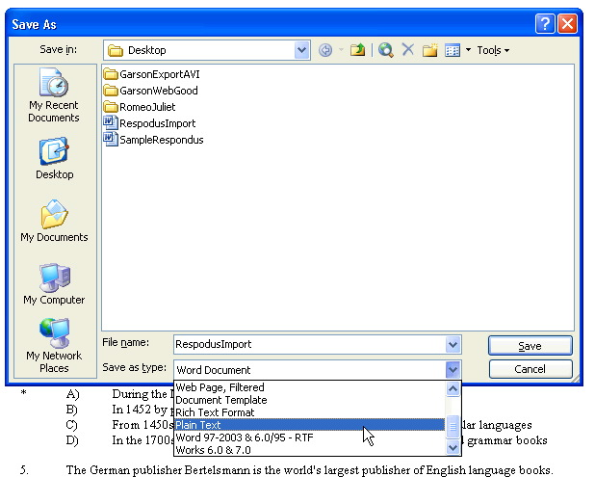
3. You will get the File Conversion window. Use the Windows Default and click OK. Your file will save. You are now ready to import files into Respondus.
